Library Model for Basic Input and Output
xUML Technical Note 014 / 27 February 2007
Ed Seidewitz / Model Driven Solutions (formerly Data Access Technologies)
(Note: This document is consistent with v11 of the fUML Execution Model.)
The Semantics of a Foundational Subset for Executable UML Models RFP includes the following requirement:

6.5.1.2 Proposals shall define a standard model library that includes the following:
- Basic data types
- FunctionBehaviors (as callable by CallBehaviorAction) to enable basic functional computation, including at least basic arithmetic, comparison functions, and logical functions
- A basic capability for receiving input into and sending output from an executing model
This technical note addresses item c, defining a basic capability for input and output. As specified in the requirement, these capabilities are provided by a library model – that is, they are defined using a set of classes that can be directly referenced from a user model, not classes within the execution model itself. However, the methods implementing the operations of these classes must be provided as primitive capabilities as part of any actual implementation of the library model.
The goal of the approach presented here is to primarily provide a simple semantic foundation for what it means to receive input into and send output from an executing model. It is not intended to be a complete input/output library, but, rather, to act as the underpinning for more sophisticated library capabilities in response to future RFPs. Nevertheless, in additional to the foundational input/output mechanism, it does also include a basic set of standard capabilities that allow the expected baseline of textual input and output.

The Model
Within the context of a single model, all communication is between known source and target elements within the model. In this sense, an executing model is a “closed universe”. Input and output is, in effect, a controlled means for providing “openings” in this universe for communications in which the actual source or target is not known within the model.
The fundamental abstraction providing for making these “openings” is that of the channel. The basic library model of channels is shown below. An input channel provides a means for receiving values into an executing model from outside of it. Conversely, an output channel is a means for sending values out of an executing model. An active channel is like an input channel, except that it allows clients to receive input values asynchronously, instead of requesting them synchronously. In addition to the fundamental channel classes, specializations are provided for basic textual input and output capabilities.

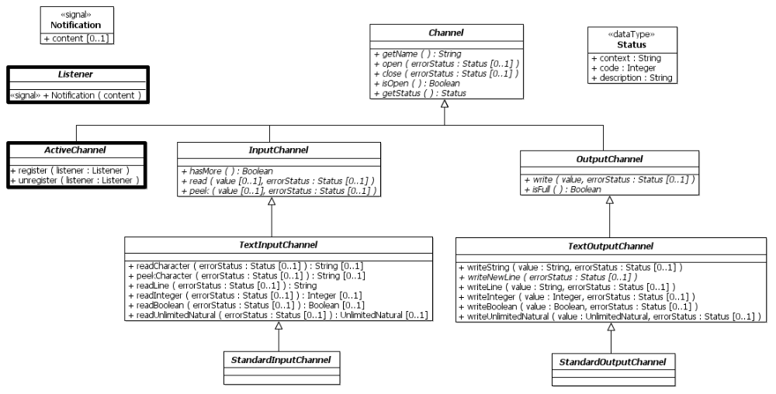
Note that all the classes in this model are abstract. They are not intended to be directly instantiated by a user model. Instead, channels must be made available as or by “services” available at the current execution locus. For example, there may be at most one instance of the class StandardInputChannel and one instance of the class StandardOutputChannel “pre-instantiated” at each locus. Or a locus may provide a file service that is used to obtain channels that connect to an external file system.
The table below provides a summary description of the classes shown in the diagram above. The following section presents some examples of how these classes could be used. The final section then gives the full descriptions of the classes.
Classifer | Description
Status | Depending on its implementation, various error conditions may develop during the use of a channel. Operations that can cause such conditions have an error status output parameter which produces a status value only if there is an error condition. It is also possible to obtain the current status of the channel, as of the completion of the last operation, directly from the channel.
Channel | A channel is a means for receiving or sending values. A channel object within an executing model represents the end of the channel accessible to that model. What is at the other end of the channel – that is the source for input or the target for output – depends on the implementation of a specific channel and is not defined by the library model.
InputChannel | An input channel is a channel for receiving input values into a model
TextInputChannel | A text input channel is an input channel whose values are text characters.
StandardInputChannel | A standard input channel is a text input channel that may be provided as a pre-instantiated service at a locus. Any locus may have at most one instance of the StandardInputChannel class, with the name “StandardInput”. Since there can be at most one instance, this instance, if it exists, can be easily obtained by executing a Read Extent action on the StandardInputChannel class.
OutputChannel | An output channel is a channel for sending output values out of a model.
TextOutputChannel | A text output channel is an output channel whose values are text characters.
StandardOutputChannel | A standard output channel is a text output channel that may be provided as a pre-instantiated service at a locus. Any locus may have at most one instance of the StandardOutputChannel class, with the name “StandardOutput”. Since there can be at most one instance, this instance, if it exists, can be easily obtained by executing a Read Extent action on the StandardOutputChannel class.
Notification | A notification is a signal with a single value (of any type) as its content.
Listener | A listener is an active class that can asynchronously receive a notification.
ActiveChannel | An active channel is similar to an input channel, in that it is used to receive input into a model. However, instead of providing input in response to synchronous requests of clients, it sends asynchronous notifications to registered listeners when input arrives.

Example Applications

Hello World
The model shown below demonstrates the use of the standard output channel to define a simple “Hello World” activity. The yellow boxes are annotations showing what kind each action is. They are not part of the model itself.
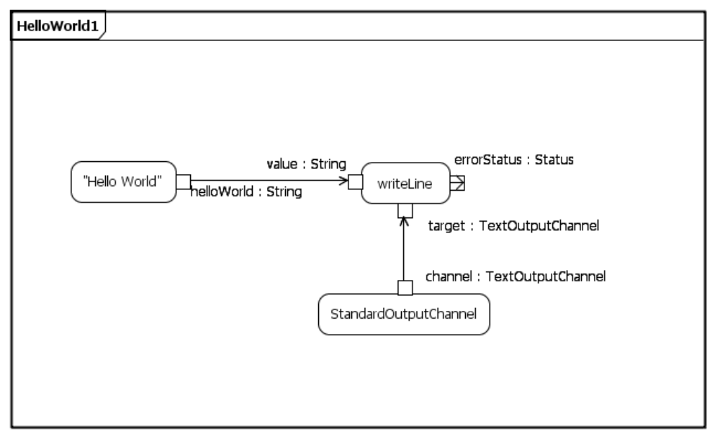
Value specification
Call operation
Read extent
As shown, the standard output channel is obtained using a read extent action on the class StandardOutputChannel. Since there is at most one instance of this class allowed at any locus, this action will produce that instance, if it exists. (If it does not exist, then the action will not produce any output and the activity will hang.) The call operation then calls the writeLine operation on this channel, with the argument value “Hello World” generated by the value specification action. (Note that, in this example, any error status output is ignored.)
This example can actually be simplified further by noticing that the general ability to write to standard output can be captured by the combination of reading the extent of StandardOutputChannel and calling the writeLine operation. Therefore, it would be useful to define this as a composite library activity, as shown below. (Similar activities for other standard read and write operations could also be included in the library.)
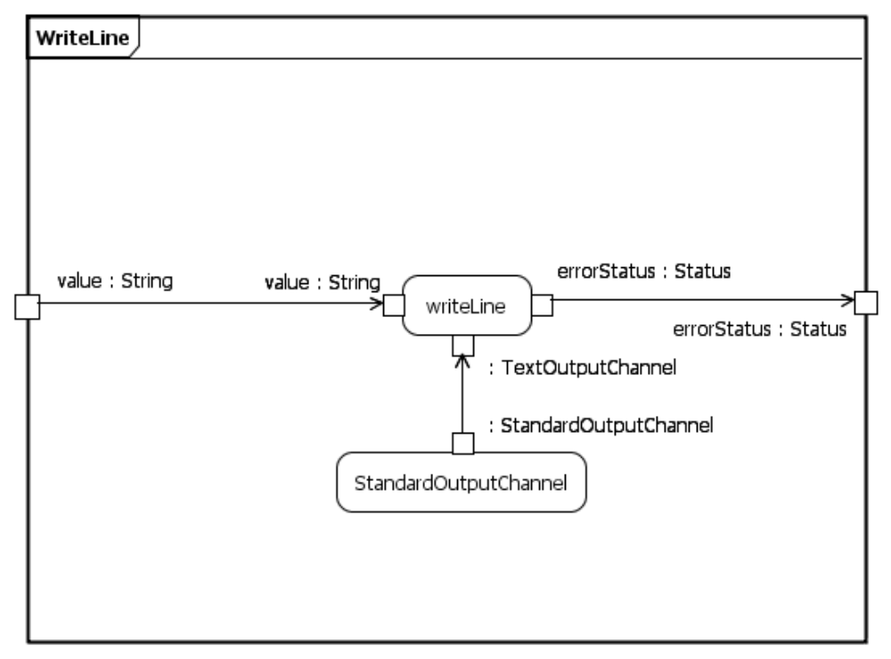
Call operation
Read extent
Using the composite WriteLine activity, the Hello World example is simply modeled as shown below.
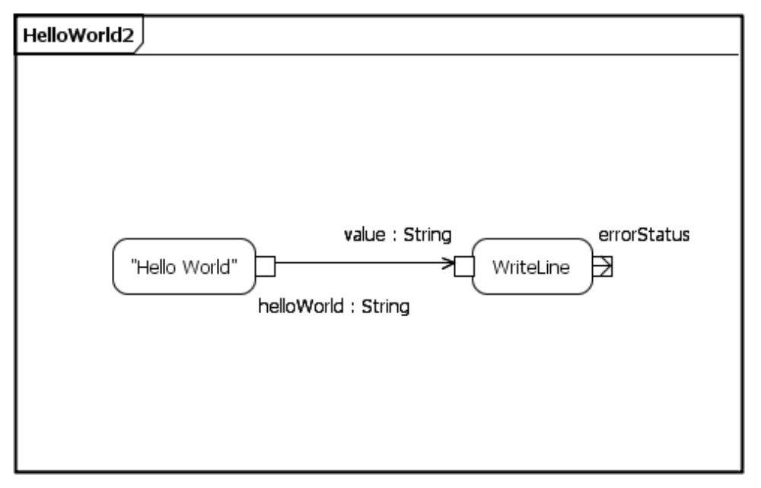
Value specification
Call behavior

Directories
Another common method of input and output is to a file system. It is not the intent to recommend here that file input/output be included as part of the foundational IO library. Such a file IO library is better left to a possible future RFP. However, this example demonstrates how an interface to a file system might be built on the foundational concept of IO channels.
Below is a very simple model for directories. This is not intended to be a fully realistic model, but it is enough to demonstrate the basic approach. This approach is to use a directory object as a means for obtaining input and output channels that connect to named files in the file system. (A more sophisticated approach might also introduce a separate File class.) The RootDirectory subclass is intended to have a single instance pre-instantiated at a locus and thus obtainable using a read extent action.
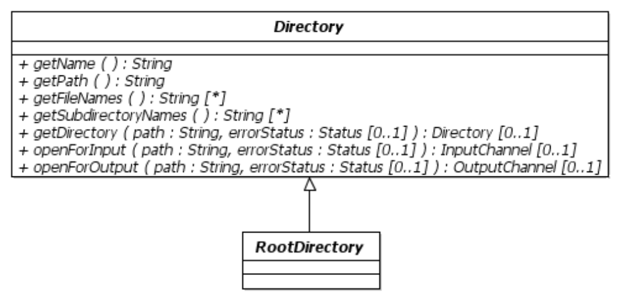
The activity below shows an example of opening a file for output, writing a text string to it and then closing it. Note that, for a text file, it is possible that the open operations would return text input/output channels, providing access to the specialized operations on those classes. If it is unsure whether a file is a text file, then the type of channel could be tested using an “is classified object” action.
The example also shows the use of the error status outputs of various operations. If an error status is produced, its description is written on the standard output. Note that if there is no error condition, then no error status is generated and the writing of the status description is never activated. On the other hand if, say, there is an error condition during the call to openForOutput, then the call completes normally, but an error status is produced instead of the expected output channel. Thus, the error description is written out, but, with no output channel being produced, the write and close operation calls are never made.
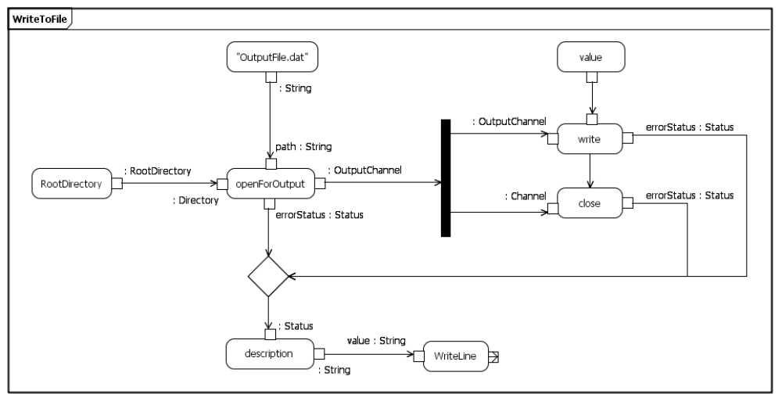
Control flow

Pipes
The previous examples have both been of cases in which, conceptually, one end of a channel is “within” a model, while the other end connects to something outside of the model execution environment – such as a text console or a file system. However, it should also be possible to have a channel the ends of which are in two different executing models – possibly at different loci.
Such a “pipe” will look like an output channel from the point of view of one of the models and an input channel from the point of view of the other model. The first model could then place values onto the pipe as an output channel, while the second model reads those values from the pipe as an input channel.
For the purposes of this example, assume that the directory objects introduced in the previous example also allow the creation of pipes by prefixing a path name in an open operation by “pipe:”. By definition, it is possible to open a pipe for both input and output at the same time, obtaining both input and output channels for the pipe. The following shows models of two different activities (potentially at different loci) communicating via a pipe.
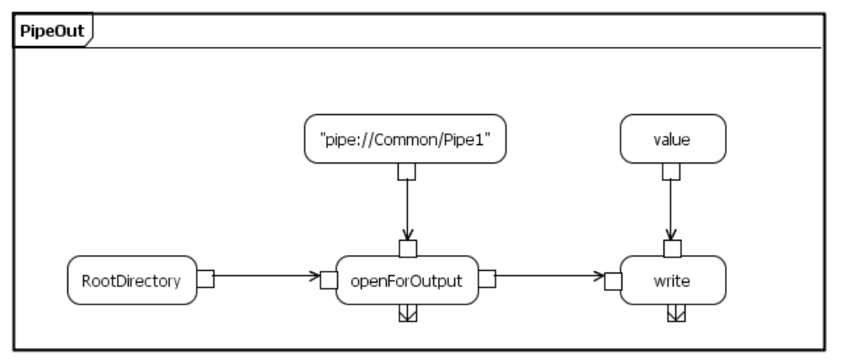
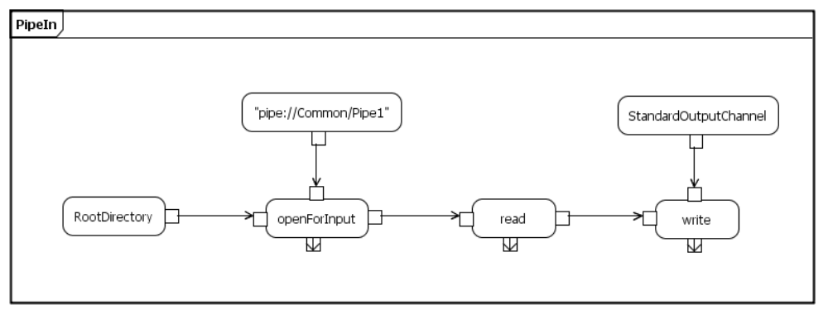

Topic Publishing
The basic input channel abstraction requires a client to make an explicit call in order to read a value from the channel. However, in many cases it is desirable for the client to wait until a value is available on an input channel and then read that value. With a regular input channel, it would be necessary for the client to poll the channel by calling the hasMore operation until it returns true. This is clumsy and prone to race conditions.
An alternative is to use an active channel. An active channel is similar to an input channel, but, instead of providing input via a read operation, an active channel sends input asynchronously to clients as it arrives. Clients thus also need to be active and they need to register as listeners with the active channel.
Consider the model below of a simplified topic publisher. When a topic is published, the topic provider receives an output channel. A topic consumer, on the other hand, receives an active channel. The idea is that content written to the output channel is sent to all listeners on the active channel. (This is similar in concept to a pipe with the input channel end replaced by an active channel.)
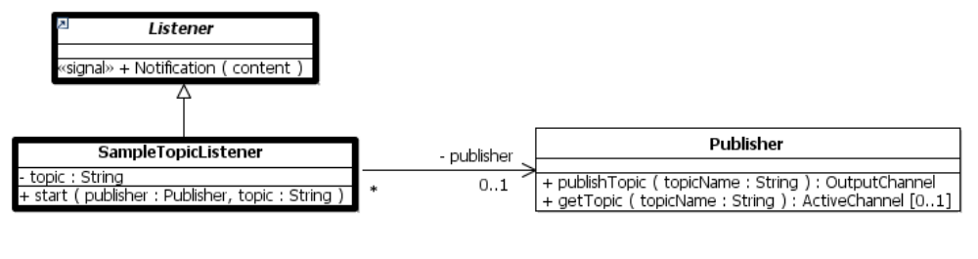
The diagram above also shows a sample topic listener. The start operation on this class sets the private topic and publisher properties and then starts the classifier behavior shown below. This behavior first registers the topic listener with the active channel for the given topic and then enters a loop in which it waits for and writes out each value it receives over that channel.
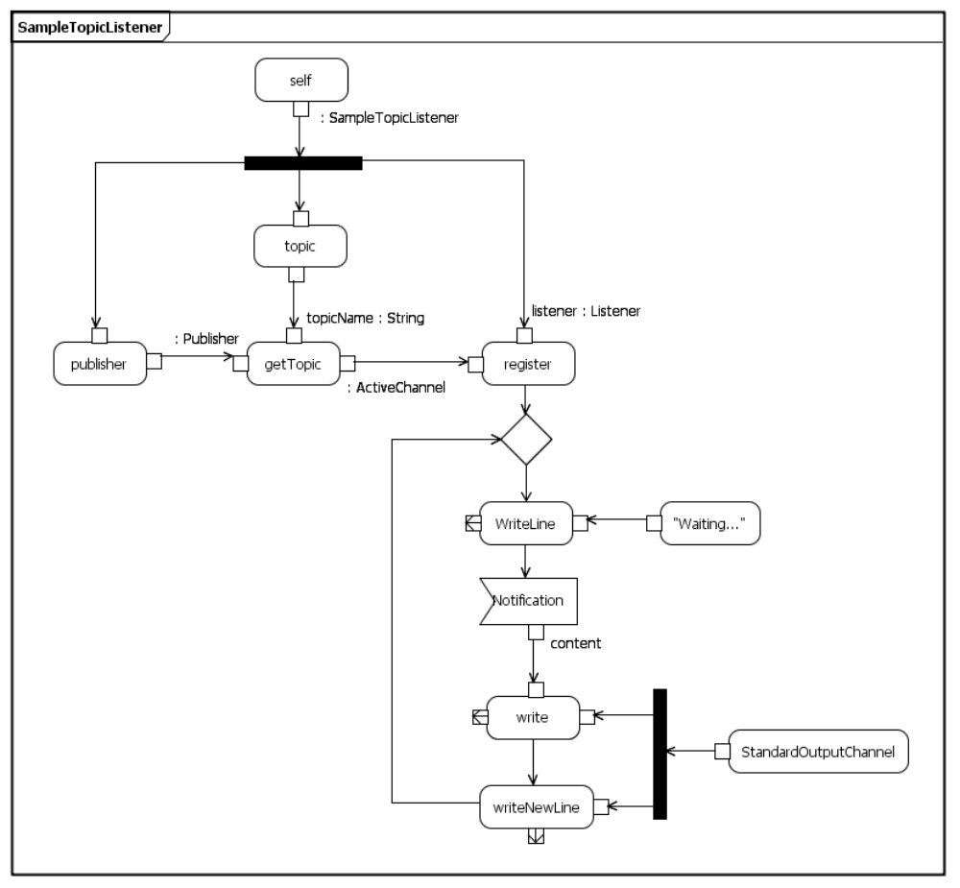
Accept event
(with unmarshalling)

Class Descriptions

Status
The Status data type provides a common structure for reporting the normal or error status of a service such as a channel. This structure consists of the following attributes.
- context: String A name (generally a class name) indicating the context in which the status is defined.
- code: Integer A numeric status code. A value of zero is the default for normal operation. A value less than zero indicates an error condition. A value greater than zero indicates an informational status condition. Status codes must be unique within a given context, but not necessarily across contexts.
- description: String A textual description of the status condition.
Operations whose execution may cause an error condition have an optional error status output parameter to report this condition. This output is generated only if there is an error condition – if the operation completes normally, no value is produced. A service may also have an operation to report its current status as of the execution of the last operation on it.

Channel
A channel is a means for receiving or sending values. A channel object within an executing model represents the end of the channel accessible to that model. What is at the other end of the channel – that is the source for input or the target for output – depends on the implementation of a specific channel and is not defined by the library model.
Two standard status codes are defined for every channel, as given in the table below. Additional status codes may be defined for specific kinds of channels (for example, see the descriptions below of the subclasses of Channel). In all cases, the name of the class in which the status is defined below is used as the context for the status code.
Code | Description | Definition
0 | Normal | The default for normal operation of the channel.
-1 | Not open | The last operation performed on the channel required the channel to be open, but the channel was closed. (All read and write operations of any sort on a channel require the channel to be open.)
getName(): String
Each channel has a name. How the name of a channel is determined depends on the implementation of a specific channel, but every channel instantiated at a given locus is required to have a different name. The getName operation returns the name of the channel.
open([out] errorStatus: Status[0..1])
A channel may be either open or closed. Attempting to receive input or send output on a closed channel has no effect. The open operation is used to open a channel that is closed. Opening a channel that is already open leaves the channel open and has no other effect.
close([out] errorStatus: Status[0..1])
The close operation closes a channel that is open. Closing a channel that is already closed leaves the channel closed and has no other effect.
isOpen(): Boolean
The isOpen operation returns true if a channel is open and false if it is closed.
getStatus(): Status
The getStatus operation returns the current status of a channel (see the description of Status below).

InputChannel
An input channel is a channel for receiving input values into a model. The following additional status code is defined for input channels.
Code | Description | Definition
-2 | No input | A read operation was attempted, but no more input is currently available on this channel.
hasMore(): Boolean
The hasMore operation returns true if there is a value available to be read from an input channel and false if there is not. The operation returns false if the channel is not open. It is an error to attempt to read from an input channel that does not have an available input.
read([out] value[0..1], [out] errorStatus: Status[0..1])
The read operation is used to obtain an input value from an input channel. The operation has value out parameter that has no type, which means that it may return a value of any type. If the read operation completes without producing an output value, then the error status is required to have an error value indicating the reason for this.
peek([out] value[0..1], [out] errorStatus: Status[0..1])
The peek operation has the same behavior as read, except that the value returned is not consumed from the input channel. That is, if the channel has an available value, multiple sequential peek calls will continue to return that same value, without removing it from the channel, until the read operation is called.

TextInputChannel
A text input channel is an input channel whose values are text characters. A read operation on a text input channel will always return a string value which contains a single character. The additional operations on a text input channel provide convenient capabilities for reading longer strings of characters and, in some cases, treating them as representations of other primitive values. The following additional status code is defined for text input channels.
Code | Description | Definition
-3 | Cannot convert | A attempt was made to read an integer, Boolean or unlimited natural, but the characters available from the channel does not conform to the required syntax.
readCharacter([out] errorStatus: Status[0..1]): String[0..1]
The readCharacter operation reads the next value from a text input channel and returns it as a string of a single character.
No value is returned if none is available from the channel. This is an error condition.
peekCharacter([out] errorStatus: Status[0..1]): String[0..1]
The peekCharacter operation has the same behavior as readCharacter, except that the character returned is not consumed from the text input channel. That is, if a character is available on the channel, multiple peekCharacter calls will continue to return that character without removing it from the channel, until some read operation is called.
readLine([out] errorStatus: Status[0..1]): String
The readLine operation continues to read characters from the input channel until the end of a line is reached or there are no more characters available from the channel. The characters read are returned, in order, as a string value. The character encoding of a new line is not defined in this specification. Nevertheless, the new line character(s) are required to be consumed by the readLine operation, but they are not included in the returned string.
Note that if no character is available from the channel when the operation is called, or if the only character(s) read are the new line character(s), then the operation returns the empty string. This is not an error.
readInteger([out] errorStatus: Status[0..1]): Integer[0..1]
The readInteger operation is used to read a textual representation of an integer and return it as an integer value. The textual syntax for an integer is defined to be an optional ‘+’ or ‘-’ character followed by a string of one or more digits ‘0’ through ‘9’. All characters are read up to (but not including) the first character that does not conform to the required syntax or until no more characters are available.
No value is returned if no characters are available from the channel or if the available characters do not begin with a string that conforms to the required syntax, in which case no values are read from the channel. This is an error condition.
readBoolean([out] errorStatus: Status[0..1]): Boolean[0..1]
The readBoolean operation is used to read a textual representation of a Boolean and return it as a Boolean value. The textual syntax for a Boolean is defined to be either the string “true” or the string “false”, or any string obtained by capitalizing some or all of the characters of these strings. All characters are read up to (but not including) the first character that does not conform to the required syntax or until no more characters are available.
No value is returned if no characters are available from the channel or if the available characters do not begin with a string that conforms to the required syntax, in which case no values are read from the channel. This is an error condition.
readUnlimitedNatural([out] errorStatus: Status[0..1]): UnlimitedNatural[0..1]
The readUnlimitedNatural operation is used to read a textual representation of an unlimited natural number and return it as an integer value. The textual syntax for an unlimited natural is defined to be either the single character ‘*’ or string of one or more digits ‘0’ through ‘9’. All characters are read up to (but not including) the first character that does not conform to the required syntax or until no more characters are available.
No value is returned if no characters are available from the channel or if the available characters do not begin with a string that conforms to the required syntax, in which case no values are read from the channel. This is an error condition.

StandardInputChannel
A standard input channel is a text input channel that may be provided as a pre-instantiated service at a locus. Any locus may have at most one instance of the StandardInputChannel class, with the name “StandardInput”. Since there can be at most one instance, this instance, if it exists, can be easily obtained by executing a Read Extent action on the StandardInputChannel class.

OutputChannel
An output channel is a channel for sending output values out of a model. The following additional status codes are defined for output channels.
Code | Description | Definition
-2 | Full | A write operation was attempted, but the channel is not able to accept any further output.
-3 | Type not supported | A write operation was attempted for a value of a type that is not supported by the channel.
isFull(): Boolean
The isFull operation returns true if an output channel is able to accept more output values and false of it is not. The operation returns true if the channel is not open. It is an error to attempt to write to an output channel that is full.
write(value, [out] errorStatus: Status[0..1])
The write operation is used to send an output value on an output channel. The operation has a single parameter. This parameter has no type, which means that it may be a value of any type. If the channel is full, then attempting a write operation is an error condition, but the operation is still required to complete its execution (which will have no other effect then to return the appropriate error status).

TextOutputChannel
A text output channel is an output channel whose values are text characters. A write operation on a text input channel always places characters onto the channel.
- For a string value, each of the characters in the string is sequentially written to the channel.
- Primitive values of types Integer, Boolean and UnlimitedNatural are written using the syntax given for the writeInteger, writeBoolean and writeUnlimitedNatural operations as described below.
- Enumeration values are written using the names of the corresponding enumeration literal.
- No standard textual representation is defined for other kinds of values, but it is not an error to attempt to write them. The actual representation of such values is determined by the specific implementation of the channel.
If, during the execution of any write operation on a text output channel, the channel becomes full, then the operation returns immediately. This is an error condition, but, if the operation was writing multiple characters, all characters up to the point the channel became full will have been successfully output to the channel.
writeString(value: String, [out] errorStatus: Status[0..1])
The writeString operation sequentially writes each of the characters in the given string value to a text output channel.
writeNewLine([out] errorStatus: Status[0..1])
The writeNewLine operation writes the character(s) encoding a new line to a text output channel. The character encoding of a new line is not defined in this specification, but is determined by the implementation of a specific channel.
writeLine(value: String, [out] errorStatus: Status[0..1])
The writeLine operation writes the given string value to a text output channel, followed by a new line.
writeInteger(value: Integer, [out] errorStatus: Status[0..1])
The writeInteger operation is used to write a textual representation of an integer. The textual syntax for an integer is defined to be an optional ‘-’ character (for a negative integer) followed by a string of one or more digits ‘0’ through ‘9’ (note that no ‘+’ is included for a positive integer).
writeBoolean(value: Boolean, [out] errorStatus: Status[0..1])
The writeBoolean operation is used to write a textual representation of a Boolean. The textual syntax for a Boolean is defined to be either the string “true” or the string “false”.
writeUnlimitedNatural( value: UnlimitedNatural,
[out] errorStatus: Status[0..1])
The writeUnlimitedNatural operation is used to write a textual representation of an unlimited natural number. The textual syntax for an unlimited natural is defined to be either the single character ‘*’ (for the “unlimited” value) or string of one or more digits ‘0’ through ‘9’.

StandardOutputChannel
A standard output channel is a text output channel that may be provided as a pre-instantiated service at a locus. Any locus may have at most one instance of the StandardOutputChannel class, with the name “StandardOutput”. Since there can be at most one instance, this instance, if it exists, can be easily obtained by executing a Read Extent action on the StandardOutputChannel class.

Notification
A notification is a signal used to asynchronously send content to a listener. It has a single attribute:
- content [0..1] An optional value (of any type) sent as the content of the notification.

Listener
A listener is an active class that can asynchronously receive a notification.

Notification(content[0..1])
The Listener class declares its ability to receive a Notification signal. Any concrete subclass of Listener should have a classifier behavior that can accept such a signal.

ActiveChannel
An active channel is similar to an input channel, in that it is used to receive input into a model. However, instead of providing input in response to synchronous requests of clients, it allows clients to register as listeners for asynchronous notification of input as it arrives. As each input value arrives, it is sent as the content of a Notification signal to all registered listeners.

register(listener: Listener)
The register operation is used to register a listener with an active channel. If the listener is already registered, then the operation has no effect.

unregister(listener: Listener)
The unregister operation is used to remove the registration of a listener with an active channel. If the given listener is not registered with the channel, then the operation has no effect.

The term “locus” is being used for the concept known as “location” in previous versions of the execution model.
This is similar in effect to what would happen if the openForOutput operation raised an exception – but exceptions are not currently included in the fUML subset.
Note that exceptions are not currently included in the fUML subset.
The read operation uses an out parameter rather than a return result because there is no UML surface syntax for displaying an operation with a return parameter that does not have a type.

